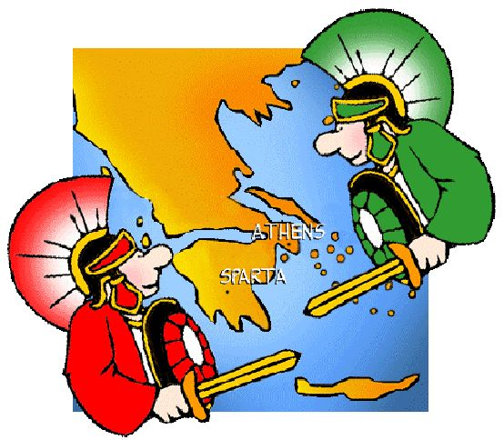
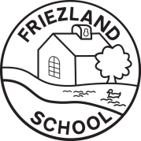
Information for Parents and Carers
Class 4: Spring Term 2

Would you rather be a Spartan or an Athenian?
English:  This half term, the children will work on story-writing skills, taking inspiration for the range of Greek Myths we have studied. Year 6 will focus on grammar content including verb tenses and Year 5 will read ‘The Wolves in the Walls’ as a stimulus for their writing. | History:  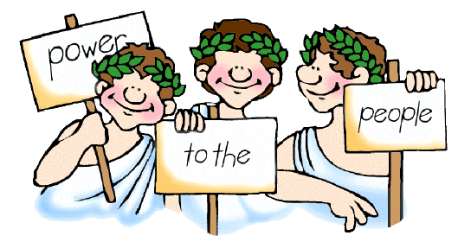  This half term, we will continue our History learning about the Ancient Greeks in order to answer the question, ‘Would you rather be a Spartan or an Athenian?’ The children will investigating aspects of daily life in different Ancient Greece states, comparing Sparta and Athens, and find out what we have learned from the Ancient Greeks. |  |  |  | Science:  This half-term, the children finish their “Living things and their habitats” topic which includes learning about the life cycles of some amphibians, mammals and insects.
PE & Games:  This half term’s PE will be Tennis on Mondays and Athletics on Thursdays.  Please ensure that your child has both indoor and outdoor kit in school at all times, as days can change if the hall is booked out or the weather is poor. Please provide trainers or pumps and bobbles to tie back long hair. |  | 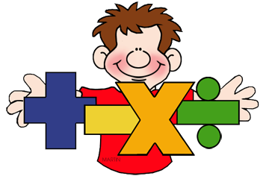  Maths:  In maths, we will build on previous knowledge of fractions, decimals and percentages to solve problems (including ratio for Year 6). Our geometry work will focus on shapes and in statistics we will interpret graphs and charts (and pie charts for Year 6). |  | How you can help at home:  To support our topic learning this term, there will be a set of HOME LEARNING CHALLENGES. The children should do a minimum of 3 each half term. These will be celebrated and shared with the class!  Children will note their home learning in their diary each week. Please sign the diary and use the comments box as a way of communicating with me; how they got on, what they enjoyed and any issues that cropped up so that I can follow it up ASAP.
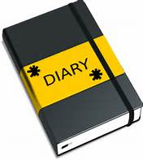  Class 4 - Dates for your diary:  - Tues 3rd & Thurs 5th March: Parent’s Evenings  - Thurs 19th March: Fire Service Visit Friezland  - Weds 25th March: Year 5 Careers Fair Trip (details to follow)  - Thurs 23rd April: Stockport Air Raid Shelter Trip (details to follow)  - Mon 11th – Thurs 14th May: Year 6 SATs Assessments |  |  | 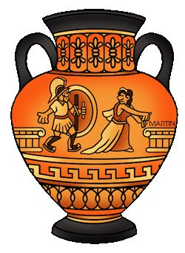  Cross Curricular Learning:  Our RE topic is about sacred texts and will cover aspects of the Christian, Jewish and Islamic faiths. In French, the children will learn the names of classroom objects and in Computing they will learn about blogging and produce a blog about their learning about the Greeks. Our Music topic is based around the song ‘Dancing in the Street’ and our Art work will be linked to history.

