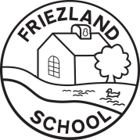
Information for Parents and Carers
Class 2: Spring Term 2

Why and How did The Great Fire of London Start?
The focus of this half term’s work is The Great Fire of London. We will learn about the key events, and about Samuel Pepys and his infamous diary. The children will increase their awareness of the past by comparing and contrasting past and present-day London, as well as looking at how life was different in the 17th century.
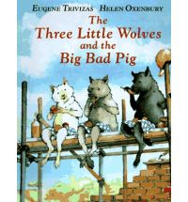  English:  Fiction – We shall be reading some traditional tales, but with a twist. We will look at the books ‘The Three Little Wolves and the Big Bad Pig’ and ‘The True Story of the Three Little Pigs’. We will learn to recite the traditional story and write our own based on the well- known version.  Non-Fiction – We will be writing some recounts and diary entries linked to our topic work.  Phonics and Handwriting are taught daily. | Maths:  In Maths we will be covering the following topics:  Addition and Subtraction  Multiplication and Division  Measures (length, weight, mass)  Fractions  Geometry (position and direction)  Time  Statistics (Yr2)  We will be using a range of resources and much of our work will involve practical activities to make the lessons fun and enjoyable. | Science:  We shall be learning to understand the differences between things that are living, dead and that have never been alive. We shall be discussing what living organisms need to stay alive and well, and then investigating the habitats they live in. The children will study simple food chains and learn how animals obtain their food.  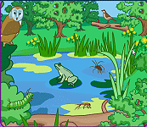  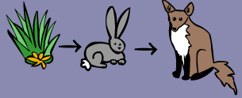
PE & Games:  This term’s PE involves Multi-Skills (where we will be improving our skills of agility, balance and co-ordination), Forest Fun (Yr1) and completing the Friezland Mile. Lessons will take place on Tuesday and Thursday afternoons. Please ensure that your child has both indoor and outdoor kit in school at all times, as days can change if the hall is booked out or the weather is poor. Long hair must be tied back for safety during the PE lessons. | Cross Curricular Learning:  PSHCE and SEAL work this half-term is entitled ‘Good to be me’. We will be exploring our feelings as an individual, developing self-awareness and considering our strengths and weaknesses as learners. For Design and Technology, we will be looking at Mechanisms. The children will be making their own moving pictures based on Traditional Tales with a Twist. In Art we are going to learn about Collage and creating pictures by tearing, cutting, folding, curling, fanning and twisting paper. We will be learning about the artist Matisse. Our focus in Computing will be Making Music. In RE our theme is entitled Questions that puzzle us. We will be looking at how Christianity and other religious traditions explore ‘big questions’ that we might ask. Our Music topic is called Round and Round when we will be learning about the elements of music through the Bossa Nova Latin Style. Forest Fun will be for Year One this half term and will be delivered by Mrs Butterworth and Mrs Hall.
Class 2 – Dates for your diary:  - 25th February – Friezland Flip  - 26th February – Wig Wednesday  - 3rd & 5th March – Parent Teacher Meetings  - 10th March – Yr2 SATs Meeting 5.30pm  - 13th March – Great Fire of London Workshop  - 23rd March – Yr1 Phonics Meeting 3.30pm | How you can help at home:  Home-learning will be set on Fridays and should be completed by the following Thursday. It will usually consist of Mathletics and TT Rock Stars activities for everyone to complete. There will also be a set of spelling words for the children to learn ready for a spelling test each Friday. Please ensure your child reads to you regularly and that an adult has written a comment in their reading record. New reading books will be given out when your child has read with an adult at school.  Finally, we are pleased to welcome Miss Yates a PGCE student From Manchester Metropolitan University who will be completing her final teaching placement with Class 2 until the end of June.

