Information for Parents and Carers
Class 4: Summer Term 1

History: Who were the Maya?
This half term, we are beginning to explore the Ancient Civilisation of the Maya. We will locate the Maya in terms of Geography and time and explore how the climate might have affected the lifestyle. We will explore Maya beliefs and the Mayan number system.
English:  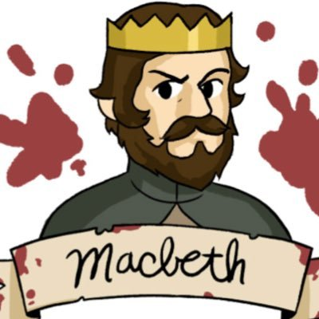  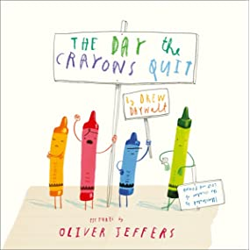  Our first unit of writing will be a persuasion text inspired by ‘The Day the Crayons Quit’ by Oliver Jeffers. Following that, we will be working on Shakespeare’s ‘Macbeth’ which includes a drama workshop day! Alongside this, we will work on reading comprehension skills with plenty of practise using a variety of genres and we will continue to work on discrete grammar and spelling rules. |  | Maths:  In Maths, we will build on our knowledge of rounding; fractions and decimals; prime, square and cube numbers. We will work on calculating, solving multi-step word problems and Y6 will learn about algebra. |  | Science & DT:  This half-term’s science topic is Electricity.  Building on their knowledge of simple circuits from Class 3, the children will test circuits and use scientific symbols to draw them. Later, they will use their skills to design, make and evaluate their own torches.
PE & Games:  This half term’s PE will be team games on Mondays and dance on Tuesdays.  Please ensure that your child has both indoor and outdoor kit in school at all times, as days can change if the hall is booked out or the weather is poor. Please provide trainers for outdoor and pumps for indoor. Children should remove their earrings or bring plasters to cover them if they can’t be taken out and have bobbles to tie back long hair. | Cross Curricular Learning:  Our RE unit this half term is based on the question, ‘If God is everywhere, why go to a place of worship?’ Our PHSE learning will focus on ‘Relationships’ including workshops about Healthy Relationships and Online Safety. In French, the children will learn to talk about parts of the body and simple ailments. |  | Class 4 - Dates for your diary:  - 23rd April: St George’s Day (Brownie/Scout Uniforms)  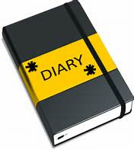  - 27th April: Parent-Teacher Meetings 1  - 30th April: Freddie Fit! (Wear PE kit for the day)  - 3rd May: BANK HOLIDAY  - 6th May: Parent-Teacher Meetings 2  - 13th May: Macbeth Theatre Workshop (£12 to pay on Eduspot)  - 20th May: PHSE Workshops - Healthy Relationships & Online Safety  - 21st May – Last day of Summer term 1  - 7th June – First day of Summer term 2
How you can help at home:
- Class 4 home-learning will be set on Fridays and should be submitted by the following Wednesday.
- It will usually consist of a piece of Maths and English work to consolidate the learning in class: It will be set on Google Classroom so if children do not have access to a tablet or computer at home, please let us know and we can arrange for them to do it in school or have a paper copy.
- There will also be a set of spelling words for the children to practise for a spelling test each Friday.
- To support our topic learning this term, there will be a set of HOME LEARNING CHALLENGES. The children should aim to do a minimum of 3 each half term. These will be celebrated and shared with the class! A copy of the home learning challenges is saved on Google Classroom.
- Please feel free to add your own comments to your child’s submitted work if you want to let me know how they got on, what they enjoyed and any issues that cropped up so that I can follow it up.
- For extra maths problem solving activities where children practice thinking like a mathematician and extending their learning, there are great websites like www.nrich.maths.org and www.parallel.org.uk and the White Rose website has a ‘Problem of the Day’ www.whiterosemaths.com/resources/classroom-resources/problems/. These links are available on Google Classroom.
Finally, it cannot be underestimated how important it is for your child to READ AND BE READ TO regularly. Please encourage them to read and share books with you to build their confidence, fluency, and passion for reading!

