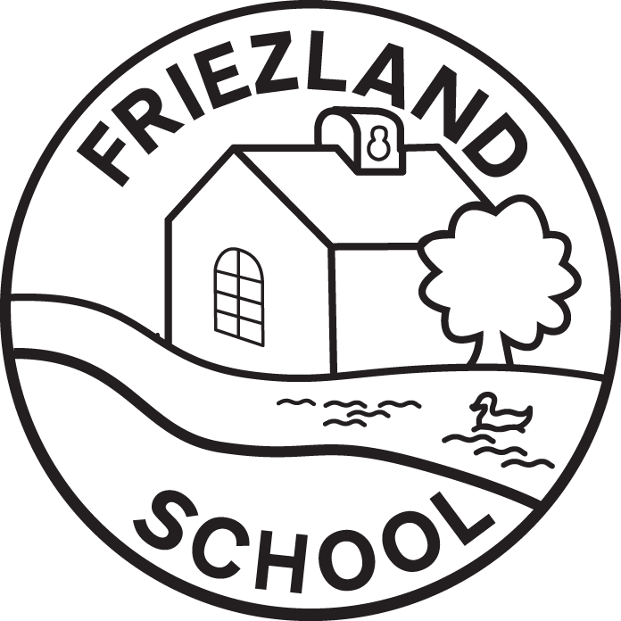
Frosties Booking Form: Spring Term 1
After School Club
Child’s Name(s): |  |  | Year group:
Week Beginning | Monday | Tuesday | Wednesday | Thursday | Friday
03.01.22
10.01.22
17.01.22
24.01.22
31.01.22
07.02.22
14.02.22
After school 1 session  3:20- 4:30 pm OR following an extra-curricular club: £4.00 |  |  | After school 2 sessions  3:20- 5:45 pm: £7.65
Please place a 1 OR 2 (number of sessions) for the sessions your child will be attending and return the form to school via your child or by e-mailing it to info@friezland.oldham.sch.uk.
I CONFIRM I WILL CREDIT MY EDUSPOT ACCOUNT PRIOR TO ATTENDANCE OF EACH SESSION

