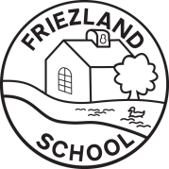
Information for Parents and Carers
Class 1: Spring Term 1

Space
Personal, Social and Emotional Development  * Friendship  * Caring for others – animals and people.  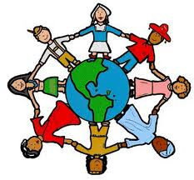  * SEAL – Going for Goals. | Communication, Language and Literacy  * Using capital letters and full stops when writing sentences.  * Sounding out the first and last sound in words.  * Understand the difference between fiction and non-fiction.  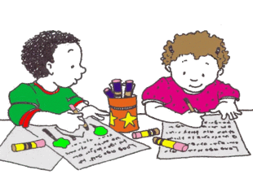 |  | Mathematics  * Understand addition as combining two sets of objects.  * Use everyday vocabulary to describe position.  * Measuring weight and length.  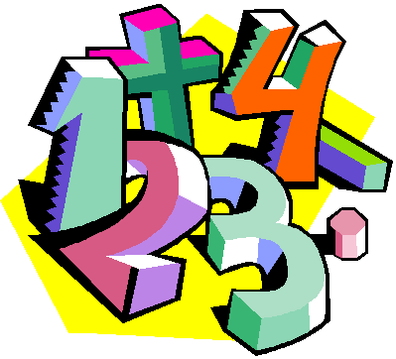  * 2D and 3D shapes.
Physical Development  * Indoor – Gymnastics (Thursday).  * Forest Fun – building fairy houses and natural art planets (Wednesday). | Understanding the World  * Name the planets in the solar system.  * Finding out about how to look after the environment.  * Finding out about materials.  * Learning about different Festivals – Eid and Chinese New Year. |  | Expressive Arts and Design  * Making rockets and space vehicles.  * Learning about dynamics in music and how to play instruments safely.  * Role play – Space Station and The Three Little Pigs Construction Site.  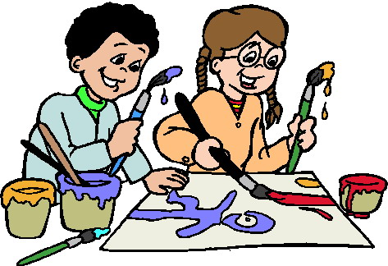
Ways in which you can help at home  * Counting up to 100.  * Showing your child the title, author and illustrator when reading story books.  * Talking about the materials used to make different objects in your home.  * Hear your child read every day. |  | We need  * All children need an outdoor PE kit (for the lunchtime club) or an indoor PE kit for gymnastics and wellies and a raincoat for outdoor play.  * Space books (these will be returned at the end of the topic).  * A small world rocket (this will be returned at the end of the topic).

