Knowledge Mat: Space

Subject Specific Vocabulary |  |  | 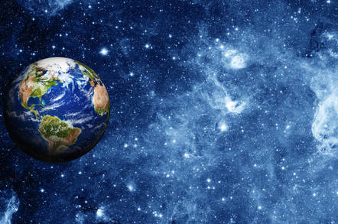 | Key Texts  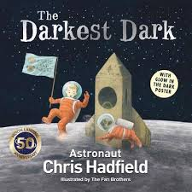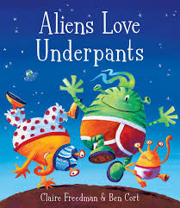  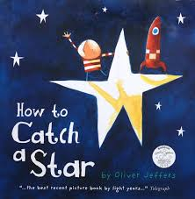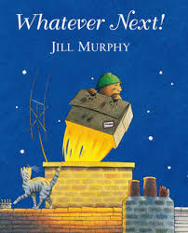  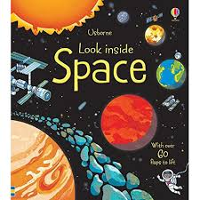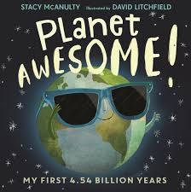
Solar System | The collection of 8 planets and their moons which orbit round the sun
Planet | Any of the worlds in space that move around the Sun
Earth | The planet we live on.
Moon | The object that goes around the Earth and shines in the sky at night. |  | Sticky Knowledge  * Name the Planets in our Solar System in order – Mercury, Venus, Earth, Mars, Jupiter, Saturn, Uranus and Neptune.  * The Earth has one moon.  * The sun reflects off the moon to light the night.  * The sun is a star.  * Neil Armstrong walked on the moon on 21st July 1969.  * Tim Peake was the first British astronaut. He stayed on the International Space Station in 2015.
Sun | The star that shines in the sky and gives the Earth heat and light.
Star | One of the tiny bright lights you see in the sky at night.
Space shuttle | A spaceship that carries people and things from Earth to a satellite and back.
Satellite | An object that moves in space
Planets
Mercury  Venus  Earth  Mars |  | Jupiter  Saturn  Neptune  Uranus

