Home Learning Challenges – How can we recreate the wonder of Ancient Egypt?
Class 3 – Spring Term, 2022
One Page Profile  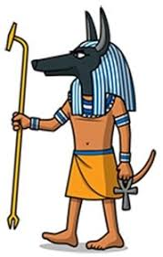  Choose an Ancient Egyptian God/Goddess to create a fact file or poster all about them. | Research  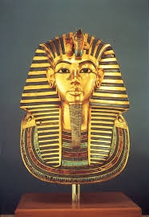  Who was Tutankhamun?  Write a short  non-chronological report about this person. | Research and prepare  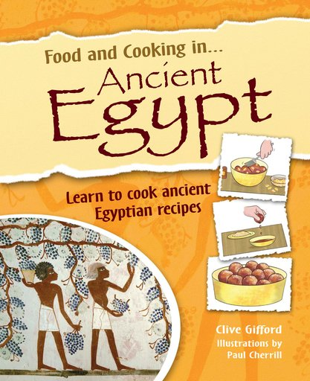  Can you research and write a recipe for an Ancient Egyptian meal? If you wanted to make it and bring in pictures that would be great!
Create  Design a piece of ancient Egyptian jewellery and draw it. Make sure it includes a symbol from that time. Eg, scarab beetle, pyramid, evil eye etc and explain what the jewellery symbolises. You could have a go at making it too!  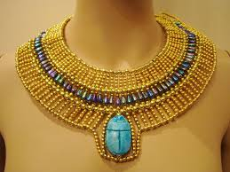 | Choose a minimum of 3 activities each half term  How can you present your learning?  Can you use ICT to help you too?  Be creative!  We will celebrate your HOME LEARNING CHALLENGES in class!  Have fun! | Code Cracking  Can you write a secret message using hieroglyphs?  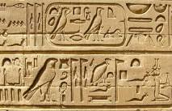 | Code Cracking  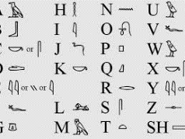  Can you create your own hieroglyphs and use them to write your name?
Research  Ask an adult to help you research the process of mummification! Write 5 gruesome facts about it!  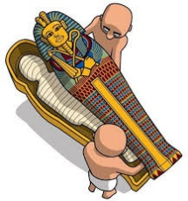 | Craft  Can you create your own ‘Ancient Egypt in a box’ model? Think about tombs, pyramids, the Nile, settlements etc.  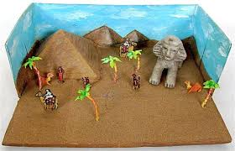 | Create  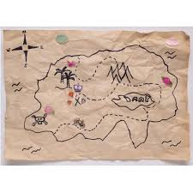  Create a map showing the key landmarks of Ancient Egypt. You could tea stain it to make it look like ancient treasure! | Out and about  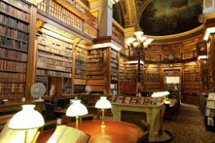  Visit your local library and find some non-fiction books on Ancient Egypt.

