Information for Parents and Carers
Class 3: Year B, Spring 1, 2022

Theme: How can we recreate the wonder of Ancient Egypt?
This Ancient Egypt unit will teach pupils in depth about the achievements of this ancient civilisation. They will learn about how and where the ancient Egyptians lived, what was important to the daily lives of ancient Egyptians, who Tutankhamun was and how mummies were made. Pupils will also learn about how Egyptian people used hieroglyphs to communicate and compare the powers of different gods. Pupils will also make their own papyrus and create prints on them.
English:  Comprehension  We will be developing our higher level interpretation skills by analysing comprehension texts.  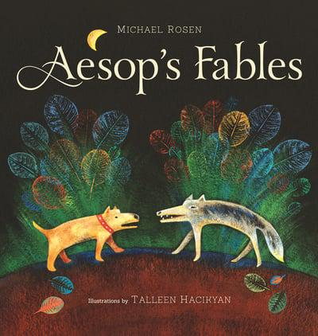  Fiction  This half term our writing will be inspired by Aesop’s Fables retold by Michael Rosen. The children will be exploring stories with morals and developing their narrative skills.  Poetry  We will be reading, interpreting and adapting classic poetry for performance. The Jabberwocky is one of the poems that will be studied. | Mathematics:  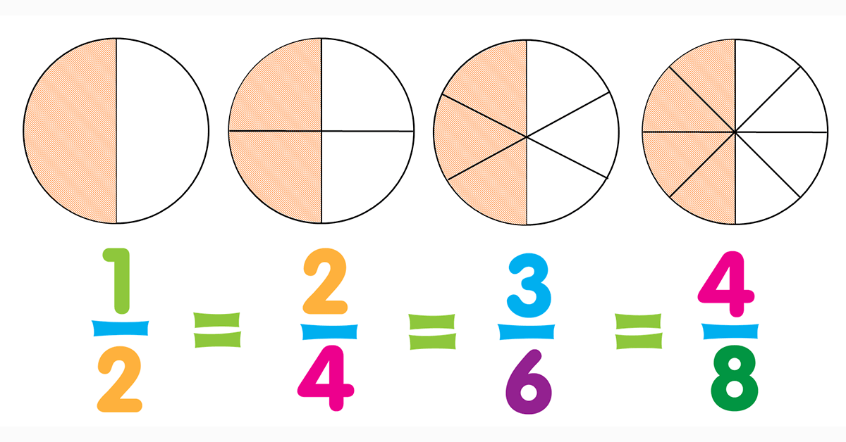  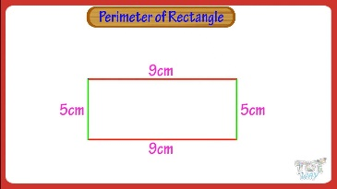  This half term we will be measuring and calculating the perimeter of simple 2D shapes and rectilinear figures (incl squares) in cm and m. We will be comparing and writing equivalent fractions, adding, subtracting and finding fractions of amounts. We will be counting up and down in tenths and hundredths and dividing numbers by 10 and 100, then rounding decimals and comparing numbers to two decimal places and finally, learning, practicing and applying written methods for division. | Science:  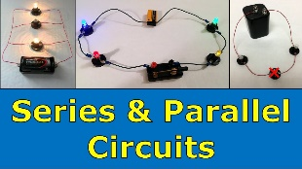  This unit is the first introduction to studying electricity in Key Stage 2. Children will learn about what electricity is and how it was  discovered. They will identify which appliances use electricity in their homes and how to keep themselves safe. Children will construct circuits, start to create pictorial circuits and conduct an investigation into how easily different types of switches can break and reconnect a circuit.
PE & Games:  This term’s PE is Gymnastics (Monday) and Swimming (Wednesday).  Please ensure that your child has both indoor and outdoor kit in school at all times as changes may have to be made.  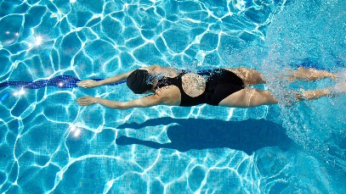 | Key Dates:  Wednesday 16th February: Freddy Fit  Wednesday 16th February: Class 3’s final swimming lesson  Friday 18th February: Friezland Flip  Thursday 10th March: Parent Teacher Meeting #1  Tuesday 15th March: Parent Teacher Meeting #2  Tuesday 29th March: Bolton Museum Visit – Egyptian Workshop  Friday 1st April: Class Photos  Additional Learning:  Children will be studying Electricals in D.T, Symbols and Religious Expression in RE, Getting to know you and animals in French, Brass in Music, Printing in Art and Spreadsheets and Writing for Different Audiences in Computing.
How you can help at home
- Please practise reading the time with your child and asking them questions like, what time is it? How long is it until your swimming lesson at quarter to 5?
- Spellings will be set on Mondays and tested the following Monday.
- A SPaG activity will be set on Fridays to be completed by the following Wednesday.
- Two Mathletics tasks will be set every Friday to be completed by the following Wednesday.
- Login to TTrockstars regularly to develop times table skills.
- A timed times tables assessment will take place every Friday.
- A home learning grid will be sent home. Pupils have the half term to complete at least three of the activities.
- For extra maths problem solving activities where children practice thinking like a mathematician and extending their learning, there are great websites like NRIC (www.nrich.maths.org) and the White Rose website for resources (www.whiterosemaths.com). On the white rose website there is a BarVember activity daily and a ‘problem of the day’. If you require any help navigating round these websites please see Miss Leigh or Miss Hodgson who will be happy to help.
Please ensure your child reads regularly to an adult. By reading with a child you are not just helping them to speed up decoding words, but also in their understanding and inference skills.

