Knowledge Mat: Science Electricity Spring 1
Vocabulary |  | Electrical Appliances Mains Power  Most big appliances in our house have to be plugged in. These are powered by mains power. Some smaller appliances can be powered by batteries. Some appliances have batteries that need to be charged by mains power. Lots of appliances around our house use electricity to work.  Battery Power  Battery powered appliances are portable which means you can use it anywhere without it having to be plugged into a plug socket. There are different types of battery for different appliances. |  | Mains Power  Mains power is produced mainly in a gas, coal or nuclear power station. Wind turbines, solar panels and hydroelectric dams are also used to produce mains power but are not used as often.  The electricity then travels from the power stations to our houses through overhead wires and pylons. We use the electricity in our house by plugging the appliance into a plug socket. Finally, the electricity enters the appliance’s electrical circuit through the wires.
Appliance | a device or piece of equipment that has been made to perform a specific task.
Battery | a small item used to power small appliances.
Circuit | a route through which electricity flows.
Components | the parts of a circuit.
Conductor | allows electricity to flow through it.
Electrical | something that uses electricity to work.
Insulator | doesn’t allow electricity to flow through it.
Mains power | electricity provided by power stations. |  | Switches  When we put a switch in an electrical circuit and turn it to the on position, it completes the circuit and allows electricity to flow around the circuit. When we turn the switch to the off position, this creates a break in the circuit meaning the electricity cannot flow anymore and the appliance will not work.
Portable | can be easily carried around.
Pylon | a tower used for keeping electrical wires above the ground.
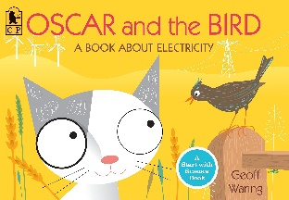
Book

