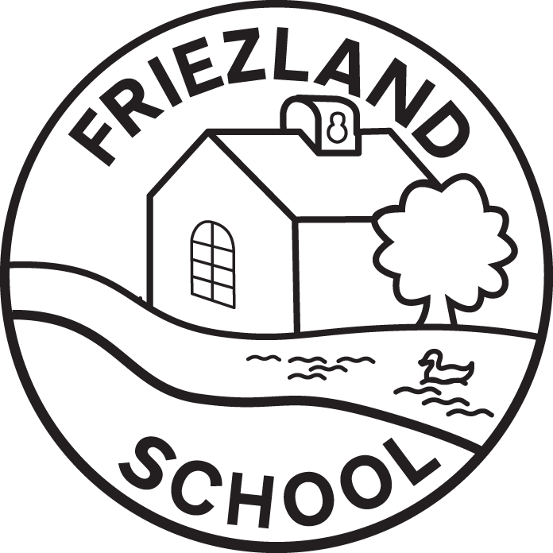
BASC: Frosties Booking Form: Autumn Term 2 2023

Child’s Name(s): |  |  | Year group:
Week Beginning | Monday | Tuesday | Wednesday | Thursday | Friday
EXAMPLE | B & A2 | - | A1 | - | B & A2
30.10.23
06.11.23
13.11.23
20.11.23
27.11.23
04.12.23
11.12.23
18.12.23 |  |  |  |  | Closed
B = Breakfast Club
7:30-8:45am: £4.70
A1 = After school 1 session  3:20- 4:30 pm OR following an extra-curricular club: £4.30 |  |  | A2 = After school 2 sessions  3:20- 5:45 pm: £7.80
Once complete, please return the form to school via your child or by e-mailing it to info@friezland.oldham.sch.uk
I CONFIRM I WILL CREDIT MY EDUSPOT ACCOUNT PRIOR TO ATTENDANCE OF EACH SESSION

