Knowledge Mat: Animals
Subject Specific Vocabulary |  |  | Key Texts  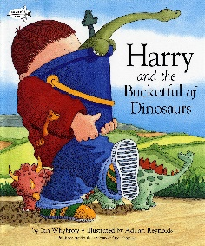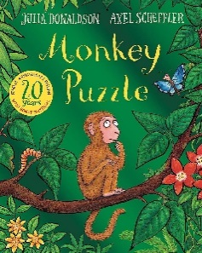  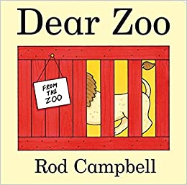
Dinosaur | 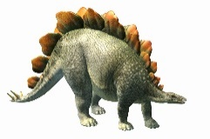 | An extinct large animal.
Carnivore | 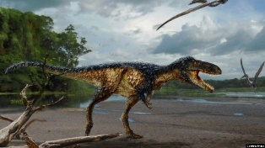 | Eats meat.
Herbivore | 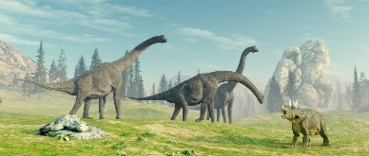 | Eats plants.
Extinct | 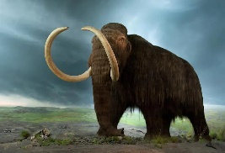 | Not living anymore.
Wild | 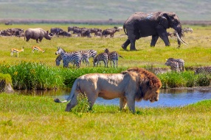 | Not looked after by people. | Wild  Tiger  Lion  Zebra  Elephant  Rhinoceros  Giraffe
Tame | 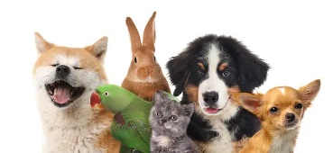 | Not afraid of people.
Carnivores  Tyrannosaurus Rex  Velociraptor  Megalosaurus  Allosaurus  Compsognathus | Herbivores  Stegosaurus  Brachiosaur  Triceratops  Ankylosaurs  Iguanodon | 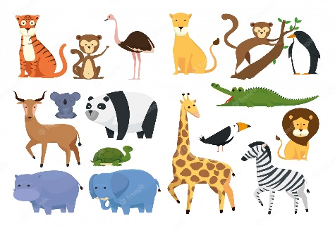 | Tame  Cat  Dog  Horse  Fish  Hamster

