17.07.2025
Before and After School Club Update
Dear families,

I am writing to tell you about some changes that are coming in September for our wraparound provision. The Governors and leaders in school have been looking at ways to develop our offer and are excited to announce that our after-school Frosties will expand to include a schedule of different extra-curricular clubs each half term (such as badminton, crafting, chess, recorders).

What’s staying the same?
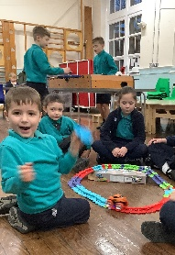
We will continue to offer a sport club with our Oldham Athletic sport coach Miss Barlow on Mondays and Thursdays until 4.15pm. In response to parental feedback, we will ensure these days alternate between KS1 and KS2 each half term to ensure that access is not restricted for children who have other activities scheduled on one of those days.

Frosties will continue to offer a wide choice of activities and games before and after school, including, but not limited to: lego, role play, table football, construction, dolls, scooters, drawing and colouring, swing-ball, outdoor games.

Children who attend Morning Frosties will continue to have a choice of cereal or toast along with milk, water or cordial for breakfast. Children who attend After-School Frosties will continue to have a snack including biscuits and fruit.

Frosties Breakfast opens at 7.30am until the start of the day at 8.45am.
Frosties After-School club closes at 5.45pm Monday – Thursday and 4.30pm on Fridays.

What’s Changing?
After-School Frosties will offer a timetable of different clubs on Tuesdays and Wednesdays each half term, so that children can choose general Frosties activities or take part in the club from 3.30 – 4.30pm. In Autumn 1, Tuesdays will be badminton club and Wednesdays will be board games club.

After-School Frosties on Fridays will become Super-Fridays! This session will include music and dancing, and the after-school snack will be a special treat!

Across the year, we will be organising themed events in Frosties to tie in with our school calendar and will be inviting guests to deliver some activities in after-school Frosties.

New Pricing Structure
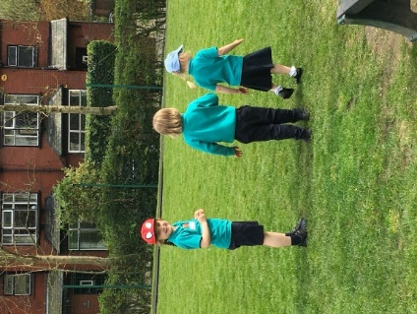
For a number of years, our before and after-school clubs have been running at a deficit with the school budget carrying the costs and unfortunately, this cannot continue. Therefore, in order to cover increased costs in staffing, resources, consumables and energy it is necessary for us to increase our prices. We have consulted with the LA and compared with providers in the local area and across Oldham to ensure that our pricing is competitive and ensures that our wraparound offer remains accessible to working families.

Frosties Breakfast = £6.00
Frosties After-School = £8.00 (flat fee)
Sport Club After-School = £8.00 (flat fee)

Because the after-school sports clubs on Monday and Thursday with Miss Barlow are part of our wraparound provision, the flat fee will be £8.00 per session and children can either be collected at 4.15pm or continue into Frosties without paying a further fee.

The 10% incentive:

If parents pay for two full weeks of Breakfast Frosties (ie: Monday – Friday, twice) a voucher email will be sent via School Spider for parents to redeem for one free Frosties Breakfast booking.

If parents pay for two full weeks of After-School Frosties – which could include sport club with Miss Barlow (ie: Monday – Friday, twice) a voucher email will be sent via School Spider for parents to redeem for one free Frosties After-School booking.

In order to receive the vouchers, each full week must be booked in advance and there are no refunds.

Conditions:
Please be aware that there is a £2.50 non-booking fee for after-school Frosties: this is when it has not been booked on School Spider by 3pm on the day and includes when children have not been collected from the playground by 3.25pm.

Please note, we do not charge a registration fee for Frosties, as most other providers do, as we manage it through our School Spider system.

Support with payments:
Parents are able to apply for support towards paying for wraparound care. You can use Tax-Free Childcare or Universal Credit Childcare to help with payments. Please check what support is available to you by looking at the childcare eligibility checker. If you would like any help or advice with using vouchers or credits to pay for Frosties, please contact Mrs Lewis in the school office info@friezland.oldham.sch.uk

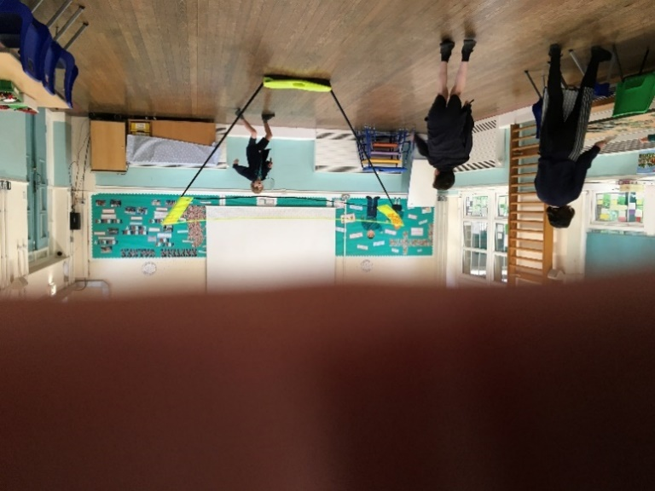
Our Autumn Term 1 sport clubs with Miss Barlow, starting in week 2, will be:
Mondays: Year 4 & 5 & 6 – Netball
Thursdays: Year 1 & 2 & 3 – Multiskills

Bookings for sport clubs and Frosties will go live on Monday 1st September. (This is due to School Spider completing their updates on 1st September.) Please wait for a message on Spider from Mrs Lewis to inform you when the system is live.

Wishing you all very happy and healthy summer.
Kind regards,
Miss Hill

