

**Frosties Information Booklet**

Welcome to Frosties

Friezland’s Before and After School Club

**SEPTEMBER 2025**



**Before and After School Club (BASC)**

Welcome to Frosties, our Before and After School Club (BASC) provision, where we aim to provide:

## a safe, happy, stimulating and well-equipped environment in which children can play and socialise;

* a wide range of activities for all ages and abilities and
* a supportive environment in which children are encouraged to participate and their individual needs met.

**The Friezland Before and After School Club (Frosties)** was established to provide a service for Friezland’s families. As such, Frosties is an extension of school and therefore school expectations, policies and procedures are followed.

Frosties is monitored by the Friezland Governing Board through the Resource & Environment Committee.

**We are a small team** but combined, our staff have many years’ experience working with and looking after children in a variety of different settings. Some of our staff work in other roles at the school and therefore, we get to know your child really well.

|  |  |
| --- | --- |
| Mrs R Moores | **Frosties Manager**  N.V.Q.3 in Children’s Care: Learning & Education  Higher Level Teaching Assistant  Deputy Safeguarding Lead  First Aid at Work |
| Mrs J Hopkins | **Frosties Assistant**  Emergency First Aid at Work |
| Mrs L Beech | **Frosties Assistant**  Emergency First Aid at Work |
| Mrs M Hudson | **Frosties Assistant** |

**The Early Years Foundation Stage** is a very important time for children, therefore as the children start school in Reception and come into Frosties, they will each be assigned a Key Person. The Key Person has the responsibility to ensure each child has their individual needs met, make sure they feel safe, has reassurance to explore new things and is helped to form new relationships.

**How to Book**

Your child needs to be booked into Frosties to ensure we provide adequate staffing to fulfil staff-to-pupil ratios and to ensure they are collected from their classroom and taken into Frosties when attending after-school care. All sessions must be booked in advance via the School Spider App. Places can be booked up to a term in advance and up to 3pm on the day.

**Opening Times and Fees**

**Breakfast Club:**

Opening Times:7.30 - 8.45 a.m. Monday to Friday

Fees: £6 (includes breakfast)

**No child can be admitted before 7.30 a.m.**

**After School Club:**

Opening Times: 3.15 - 5.45 p.m. Monday to Thursday

3.15 - 4.30 p.m. Friday

Fees: £8 (includes snack)

If your child attends an after-school sport club until 4.15pm on Mondays or Thursday, prior to attending Frosties, you will NOT be charged further for attending Frosties afterwards.

**Late fee: £5** per child for every 10 minutes they remain uncollected after 5:45pm Mon-Thurs / 4.30pm Fri.

**Refunds:** Bookings will not be refunded if your child does not attend. Bookings can be cancelled via the School Spider App up to 3pm on the day.

**Non-booking fee (after-school care):** A place can be booked on the School Spider App up to 3pm on the day. A fee of **£2.50** will be added to your child’s account for those who have not booked a place, in advance, via School Spider. Where this happens, staff will try to contact a parent/carer.

Breakfast Club booking closes on the app at 7.30am HOWEVER you can bring children to breakfast club up to 8.45am on the day and occur no additional charge.

**Individual circumstances are always considered.**

Our school procedures for uncollected children are available on request.

**Payment**

* Frosties is a pay-in-advance service. **Payment is to be made in advance at the time of booking,** via the School Spider App.
* Childcare voucher payments are also accepted. Parents can add their vouchers directly onto the School Spider App and school will then verify these vouchers once payment has landed in our account. You are still able to use this money while waiting for it to be verified.
* We will chase up any unpaid Frosties fees to ensure that debt is not accrued. Should Frosties debt be nearing £100, we will contact you to discuss a payment schedule. Should Frosties debt exceed £100, you will no longer be able to book your children into Frosties until payment hs been received and a payment schedule is in place.

**Dropping off Children in Breakfast Club:**

* Please bring your children to the main entrance and ring the Frosties bell. A member of staff will come and collect your child and sign them into the club.
* They will take your child to the hall for breakfast and time to play.

**Collection of Children in After-School Club:**

* Please ring the Frosties bell at the main entrance. A member of staff will then bring your child to you and confirm the time of signing out with you. If the children are playing outside, your child will be handed over at the school gate.
* If you arrange for someone different to collect your child, please let us know beforehand by telephoning school on 01457 872601. Please ensure the person collecting your child knows the two-word password you provided to school.

**Refreshments:**

Breakfast is provided during the morning session and consists of a choice of: cereal, toast, apple juice, orange juice, milk or water.

During the evening session, a variety of snacks are available along with drinks of water. Friday sessions include an additional ‘special’ snack(eg: waffles, ice lollies, mini-pancakes).

**Allergies and Dietary Requirements:**

If your child has any allergies or dietary requirements, please provide this information on their school registration form and discuss it in more detail with the Frosties Manager, Mrs Moores, if necessary.

**Activities:**

## A wide range of activities are offered and include:

* outdoor games including football, skipping, tennis, scooters & climbing frames
* art and craft activities
* construction including Lego, Knex, Meccano
* board games including Chess, Monopoly, Connect 4
* role play and dressing up
* reading a book, listening to music or chatting with friends.

We do like to play outside as much as possible, therefore in colder months it may be necessary to send your child with additional clothes to ensure they stay warm.

A schedule of activities will be announced for each half term for specific days, such as Badminton on Tuesdays or Chess on Wednesday.

Activities are planned for festivals such as Chinese New Year & Divali, as well as special events to tie in with the school calendar, and a range of visitors are invited across the year to deliver activities in Frosties.

Friday after-school sessions are ‘Super-Fridays’ which include music, dancing and a special snack.

**Friezland Expectations:**

Frosties thrives in an atmosphere of mutual respect where, in line with our Behaviour Policy and Friezland Expectations, appropriate behaviour is positively reinforced.

It is our belief that if children are motivated, occupied and happy, inappropriate behaviour is discouraged. Staff are experienced in using a range of strategies to diffuse inappropriate behaviour, but if this is persistent it may result in the loss of a place.

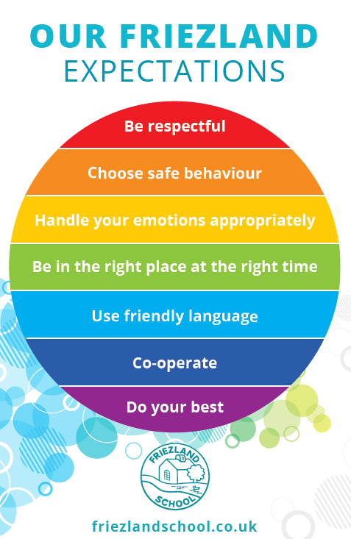

**Illness and Medication:**

* Parents or guardians will be notified immediately on the emergency contact numbers, if a child is unwell or has a serious accident. It is therefore very important to inform school of any change to these numbers/details.
* Our ‘Administration of Medicines Policy’ includes details of procedures to be followed if your child needs to take prescribed medication. Members of staff may only administer essential medication.
* Frosties staff have undergone training in emergency first aid and are well equipped to deal with minor injuries, should they arise.

**Contact Details:**

School Phone Number: 01457 872601 / 0161 770 3700

School Email address: [info@friezland.oldham.sch.uk](mailto:info@friezland.oldham.sch.uk)

**Policies:**

A number of policies guide us in our implementation of various practices and procedures. All our policies are available to read upon request.

**Equal Opportunities:**

We acknowledge that all users of Frosties have individual requirements, and as such, as Equal Opportunity providers, we aim to ensure that these requirements are met.

**Safeguarding and Child Protection:**

Frosties Safeguarding and Child Protection Policy, contributes to the personal safety of all children using its facilities, through actively promoting an awareness of procedures and good practice. Frosties staff have responsibility for the implementation of this policy. The Frosties Manager is a Designated Safeguarding Lead for the school.

**Complaints Procedure:**

We hope you will have no need to use the complaints procedure, however, if you do:

* Please speak to the Frosties Manager, Mrs Moores, in the first instance.
* If the matter is not resolved, the Headteacher should be contacted.
* If the matter remains unresolved, please complete the School Complaints Procedure Form & send to Chair of Governors, via Business Support, Rock St. Centre, Rock St, Oldham, OL1 3UJ.
* The Chair of Governors will acknowledge receipt & explain what action will be taken.
* You may also contact OFSTED with any compliments, complaints or concerns. A leaflet ‘Guidance for Parents’ is available on the OFSTED website: [www.ofsted.gov.uk](http://www.ofsted.gov.uk)

Grievances may be addressed to: *Early Years, OFSTED, 3rd Floor, Royal Exchange Building, St. Anne’s Square, Manchester. M2 7LA, quoting our reference number – 105666.*

**Data Protection:**

All information we collect from you will be handled in accordance with the school’s Data Protection Policy.

|  |  |  |  |  |  |
| --- | --- | --- | --- | --- | --- |
| **Data Audit for Frosties** | | | | | |
| **What?** | **Probable Content** | **Why?** | **Who?** | **Where?** | **When?** |
| Pupil and carer information | Name  D.O.B.  Carer phone numbers  Home address  Email address  Medical information  Sibling information (if attend this school) | In case of emergency  Well-Being of Your Child  To support fees and administration | All Staff  (as necessary) | Paper / electronic copies filed securely  Email and phone numbers on School Spider and locked in the school office | Held on File and renewed annually  Data is deleted / shredded annually or as a child leaves the school. |

As such, our assessment is that this information handling:

|  |  |  |
| --- | --- | --- |
| **Has Few / No Data Compliance Requirements** | **Has A Moderate Level of Data Compliance Requirements** | **Has a High Level of Data Compliance Requirements** |
|  | ✓ |  |



**FROSTIES Parent / Carer Fire Evacuation Procedure**

As we carry out regular fire drills in Frosties, we would like to bring to your attention our safety procedures for evacuating the school, should you be dropping your child(ren) off for breakfast club or collecting from Frosties after school care, at that time.

Parents/Carers do not usually enter the school building as you are requested to drop/collect your child(ren) from the main entrance.

* If you hear the alarm when you are approaching the building / grounds, do not attempt to enter the building. Please keep yourself (and your child if en-route to breakfast club) safe and wait beyond the school grounds for further instructrions.
* If you are on the school grounds, make your way to the assembly point which is located on the pathway next to the field. You will see white markers on the wall. Please line up next to the ‘V’ visitor marker.
* If you are in the school building when the alarm sounds, please make your way to the nearest exit. These are at the 4 corners of the building. Make your way to the assembly point which is located on the pathway next to the field. You will see white markers on the wall. Please line up next to the ‘V’ visitor marker. Your child(ren) should line up in their year group line e.g. 1 for Year 1.
* At the assembly point the Fosties Manager or lead member of staff will take the register. Please do not take your child away until this has been completed.

Thank you for your co-operation with ensuring we are all kept safe.

**The Frosties Team.**