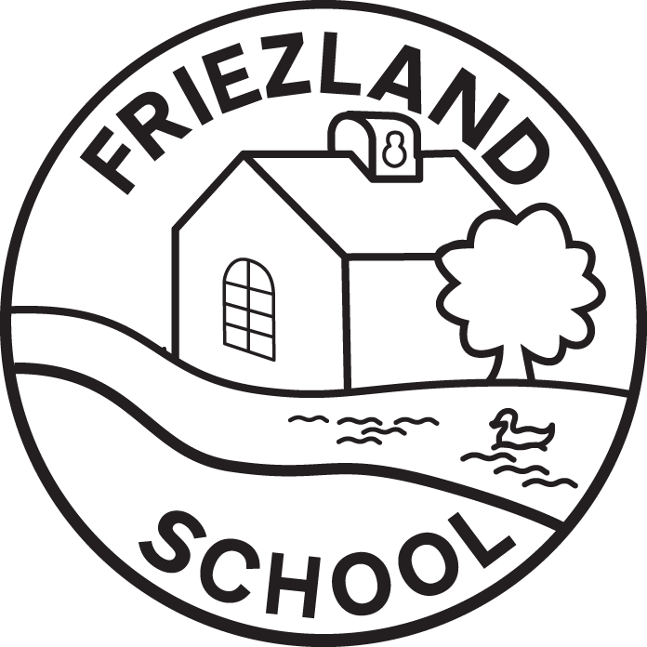

Allergies including Nut & Food Allergy

Written / reviewed by | R Hill
Date written / reviewed | April 2025
Date of next review | April 2028
Headteacher | R Hill
Chair of Governors | J Goodwin

Statement of Intent:
This policy is concerned with a whole school approach to the health care and management of those members of the school community suffering from specific allergies.

Friezland Primary School are aware that children who attend may suffer from food, bee/ wasp sting, animal or nut allergies and we believe that all allergies should be taken seriously and dealt with in a professional and appropriate way.

Friezland Primary School’s position is not to guarantee a completely allergen free environment but rather to minimise the risk of exposure, encourage self-responsibility, and plan for effective response to possible emergencies.

The Statutory Framework states that the provider must obtain information about any dietary requirements/allergy. As such parents are asked to provide details of allergies in the child’s ‘Data Collection’ form, which is submitted before starting school.

Aim:
The intent of this policy is to minimize the risk of any child suffering allergy-induced anaphylaxis whilst at school. The underlying principles of this policy include:
- The establishment of effective risk management practices to minimise the pupil, staff, parent and visitor exposure to known trigger foods and insects.
- Staff training and education to ensure effective emergency response to any allergic reaction situation.

This policy applies to all members of the school community including: School Staff, Parents / Guardians, Governors, Volunteers, Supply staff, Students.

Definitions:
Allergy – A condition in which the body has an exaggerated response to a substance (e.g. food and drug) also known as hypersensitivity.
Allergen – A normally harmless substance that triggers an allergic reaction in the immune system of a susceptible person.
Anaphylaxis – Anaphylaxis, or anaphylactic shock, is a sudden, severe and potentially life-threatening allergic reaction to food, stings, bites, or medicines.
Epipen – Brand name for syringe style device containing the drug Adrenalin, which is ready for immediate inter-muscular administration.
Minimised Risk Environment - An environment where risk management practices (e.g. Risk assessment forms) have minimised the risk of (allergen) exposure.
Health Care Plan- A detailed document outlining an individual student’s condition treatment, and action plan for location of Epipen.

Procedures and Responsibilities for Allergy Management:
General
- Both parents and staff should be involved in establishing individual Health Care Plans.
- Effective communication regarding a child’s healthcare plan should be established and involve all relevant staff.
- Regular staff training in anaphylaxis management if needed, including awareness of triggers and first aid procedures, including Epipen training, is to be followed in the event of an emergency.
- Age appropriate education of the children with severe food allergies should be established by school and parent(s).

Medical Information
- Parents/Guardians must report any change in a child’s medical condition during the year to the school.
- For students with an allergic condition, the school requires parents/guardians to meet with a member of SLT to ensure the school has all required information. Where relevant, a Health Care Plan will be created which is checked by the Head Teacher and advice sought from the school nurse if required.
- School Leaders will ensure that a Health Care Plan is established and updated for each child with a known allergy.
- Teachers and teacher assistants of those students and key staff, including catering staff, are required to review and familiarise themselves with the medical information.
- Whole School Allergies and Medical Conditions list, with a recent photograph for any students with allergies, will be posted in relevant locations around sschool with parental permission.
- Where pupils with known allergies are participating in school excursions, the risk assessments must include this information.
- The wearing of a medic-alert bracelet is allowed by the School.

Medical Information – Epi-pens
Where Epi-pens (Adrenalin) are required in the Health Care Plan:
- Parents/guardians are responsible for the provision and timely replacement of the Epi-pens.
- Epi-pens are to be located securely in the school office.

Parent's role:
Parents are responsible for providing, in writing, up to date, accurate and current medical information to the school.

Parents are to notify the school on the relevant medical form, confirming and detailing the nature of the allergy; including:
- the allergen (the substance the child is allergic to)
- the nature of the allergic reaction (from rash, breathing problems to anaphylactic shock)
- what to do in case of allergic reaction, including any medication to be used and how it is to be used
- control measures – such as how the child can be prevented from getting into contact with the allergen
If a child has an allergy requiring an Epi-pen, or the risk assessment deems it necessary, a Health Care Plan must be completed and signed by the parents.
It is the responsibility of the Parent to provide the school with up to date medication/equipment clearly labelled in a suitable container. In the case of life saving medication like Epi-pens the child will not be allowed to attend without it. Parents are required to provide up to date emergency contact information.

Snacks and lunches brought into school are to be provided by the child’s parent. It is their responsibility to ensure that the contents are safe for the child to consume. Parents should liaise with staff about appropriateness of snacks and any food-related activities (e.g. cooking).

Staff’s role:
Staff are responsible for familiarising themselves with the policy and to adhere to health & safety regulations regarding food and drink.

If a child’s Medical Form states that they have an allergy, then a Health Care Plan may be needed. It must be in place before the child starts attending school. A risk assessment should be carried out and any actions identified should be put in place. The risk assessment should be stored with the child’s Health Care Plan.
The Head Teacher will determine if a ban on certain foods is needed after consultation with the parent/guardian and health professionals. If appropriate, this will then be publicised to the whole school community.
All staff who come into contact with the child will be made aware of what treatment/medication is required and where any medication is stored.
Teachers and key support staff will:
- promote hand washing before and after eating.
- monitor snack time and the ingredients of snacks
- be informed of the procedures at snack and lunch time to ensure the safety of children with allergies.
- liaise with parents about snacks and any food-related activities.
- ensure that children are not permitted to share food unless part of a planned activity that the teacher has risk assessed.
- ask the parent for a list of food products and food derivatives the child must not come into contact with.

Catering staff will maintain a list of known allergens in the school meal menus and these can be shared with parents and guardians if requested.

However, staff cannot guarantee that foods will not contain traces of nuts.
Staff are trained in first aid, including Epi-pen use and storage. Emergency medication should be easily accessible, especially at times of high risk.
Actions:
In the event of a child suffering an allergic reaction:
- Check to see if there is a known record of the allergy / Health Care Plan and follow instructions.
- If no Health Care Plan and the child is suffering serious symptoms ring 999 and follow advice.
- Contact parent to advise or ask for advice if less serious symptoms.
- Calm and reassure the child.

