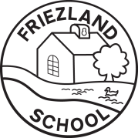
Information for Parents and Carers
Class 1: Autumn Term 2

“Which Festivals do You Celebrate?”
The focus of this half term’s work is learning about different festivals and how they are celebrated. The children will learn the key vocabulary, celebration, present, candle, birthday, bonfire and remembrance.
Personal, Social and Emotional Development  This term we are focussing on using our senses and continuing to develop our understanding of emotions and feelings. In our Think Equal sessions, we are learning about kindness and what we can do to be kind to others.   | Communication, Language and Literacy  Every Monday we will talk about our weekend news.  In Phonics we will be beginning to learn about digraphs (2 letters which make 1 sound) and using these to spell simple words.  We are going to use the story ‘That’s not my snowman…’ to begin to identify and use adjectives in our writing.   |  | Mathematics  In Maths we are going to learn about the regular 2D shapes and are continuing to learn about subitising (knowing how many is in a set without having to count the objects) and recognising number bonds for numerals 1-5.  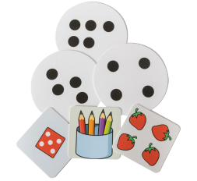
Physical Development  This term our PE sessions are indoors for dance (Thursday)  In Forest Fun we are going to learn about garden birds and how we can look after them (Friday).  Please ensure that your child always has their indoor PE kit and wellies in school as days can change because of poor weather.  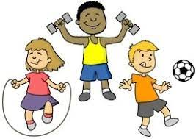 | Understanding the World  Throughout our topic work we will be finding out about the festivals of Diwali, Hannukah, Eid and Christmas. We will learn how and why each festival is celebrated and will compare the similarities and differences between each celebration.  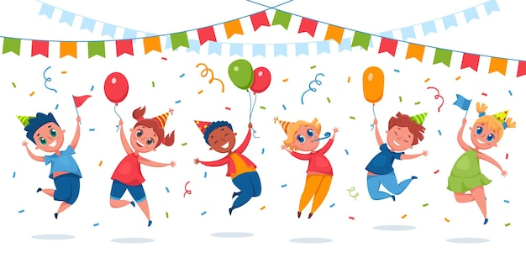 |  | Expressive Arts and Design  Our Art topic focusses on painting and creating a self-portrait. In DT we will be using clay to make a Diwali lamp.  Our music topic is called ‘My Stories!’ in which we will explore listening to music and learning to sing some Nursery Rhymes.  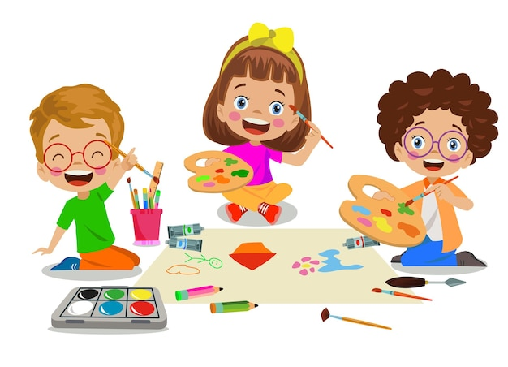  This term our role play is a birthday house and later in the term ‘Santa’s Grotto.’
Ways in which you can help at home  * Listening to your child read every night and practice sound cards.  * Play counting games – matching items to number cards.  * Complete the challenges on Purple Mash (log-in details in reading record)  * Learning the words for ‘Away in a Manger’.  * Talk about Christmas and other celebrations – look at photographs from previous years. |  | Class 1 Dates for your diary:  * 6th or 11th Nov – Parents Evening 3.30-6.00pm  * 13th Nov – Chinese Lunch  * 27th Nov Friends of Friezland Class 1 and 2 Christmas Tumbles Party  *5th Dec – Whole School Christmas Celebration @ Friezland Church 9.30 – 10.30  * 10th Dec 2pm or 6pm – Class 1 and 2 Nativity in school hall – more details to follow  * 12th Dec – Travelling Theatre Company Christmas Show – in school  * Thursday 18th Dec – Break up for Christmas holiday

