
Information for Parents and Carers
Class 2: Autumn Term 2
Why Do We Celebrate Bonfire Night?
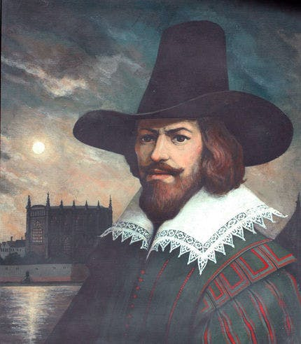
The focus of this half term’s History work is to learn about the story of Guy Fawkes and his plan to blow up King James and the Houses of Parliament in 1605. The children will find out about individuals involved in the plot including Guy Fawkes, Robert Catesby and Thomas Percy. Activities like speaking and listening, hot seating, role play, sequencing events and designing posters will make our learning exciting. We have a special visit from the company ‘One Day Creative’ who are running an exciting and educational workshop for us too.
English:  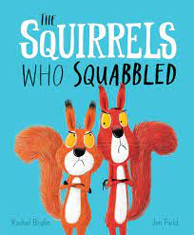  We are going to use the stories ‘The Squirrels who Squabbled’ and ‘Stanley’s Stick’ to help us learn how to write a recount and to also create descriptions of the characters that appear in the stories and where they are set.  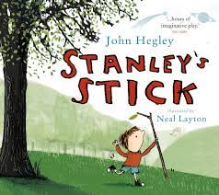  Phonics will be taught in Year 1 and Spellings in Year 2 using the ‘Essential Letters and Sounds’ programme.  Handwriting (learning to write in a cursive style) and Reading Comprehension lessons also take place in Y2. | 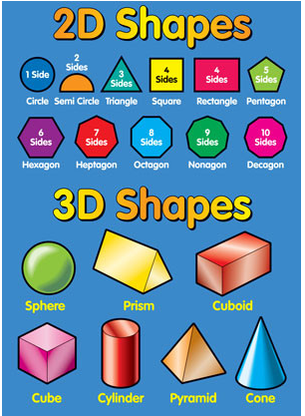  Maths:  In Maths we will be covering the following topics:  - Numbers and Place Value within 100    - Shape  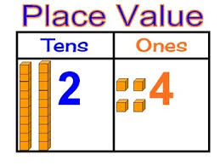 |   Science:  This half term’s Science topic is Everyday Materials.  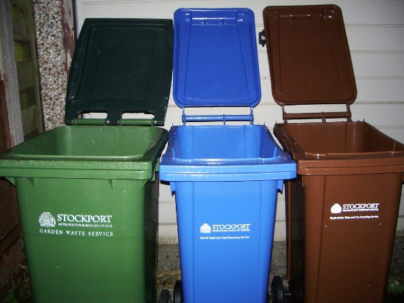  We will be learning about the uses of everyday materials including wood, plastic, metal, glass, brick, paper and cardboard. We will compare the suitability of different everyday materials for different purposes. We will then explore how objects made from some everyday materials can change shape and how the recycling process is able to reuse some everyday materials numerous times.
PE & Games:  This term’s PE lessons involve Netball/Basketball with the sports coach (Mon and Thurs).  Please ensure that your child always has both indoor and outdoor kit in school, as days can change if the hall is booked out or the weather is poor. Long hair must be tied back for safety during the PE lessons. | How you can help at home:  Home Learning will be set on Fridays and should be completed by the following Thursday. It will consist of Mathletics and a set of spelling words for the children to learn ready for a spelling quiz each Friday. Year 2 will also need to begin to practise their 2, 5 and 10 X tables.  Please ensure your child reads to you regularly and that an adult has written a comment in their reading record. It is important that your child has their reading book in their school bag every day. New reading books will be given on Mondays.
Class 2 – Dates for your diary:  - 10th November – Odd Socks Day for Anti-Bullying  - 11th November – Parents Evening 2  - 18th November – Latics Player Visit  - 21st November – Guy Fawkes Workshop  - 28th November – Break the Rules Day | - 5th December – Carol Concert at Church 9.30  - 9th December – KS1 Dress Rehearsal  - 10th December  - 12th December – Travelling Theatre  - 16th – Xmas Jumper and lunch day  - 17th – KS1 Christmas Party  FRIDAY 19th December – INSET DAY – SCHOOL CLOSED |  | Cross Curricular Learning:  PSHE Ed – ZIPPY Beating Bullying and Computing Online Safety  Art – Painting and Mixed Media: Life in Colour  Computing – Programming and Animations RE – Why are festivals important in a community?  DT – Designing and making a chair for Baby Bear.  Music – Busy Busy Bethlehem (KS1 Nativity)

