Information for Parents and Carers
Class 3: Year B Autumn 2 2025
Theme: What Makes the Earth Angry?
This half term will see us continue with the theme of ‘What Makes the Earth Angry?’ for our Humanities topic. Children will describe and understand key aspects of physical geography including volcanoes and earthquakes. They will know what causes an earthquake, be able to label the different parts of a volcano and know what a tsunami is. Finally, they will be able to identify the position of latitude and longitude, equator, northern and southern hemisphere and the Tropics of Cancer and Capricorn.
  English:  Fiction  This half term our writing will be inspired by the book ‘Eye of the Wolf’ by Daniel Pennac. Our higher-level interpretation skills will be developed using Literacy Shed Vipers resources. The children will also be exploring the characters and developing their narrative skills.  Non-fiction  We will develop our non-fiction writing skills later in the term by learning about the features of non-chronological reports. We will then plan and write one of our own from independent and class based research linking to our science topic. | Mathematics:  This half term the topics being covered in Maths are:  Addition and Subtraction  Multiplication & Division  Area  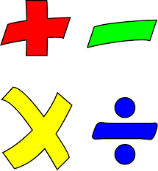  . | Science:  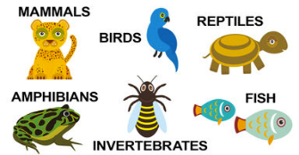  We will be learning about Living Things and their Habitats.  We will be learning how to classify living organisms into  various groups. The children will be exploring a variety of  classification keys by learning about warm and cold  blooded organisms, those classed as vertebrates and  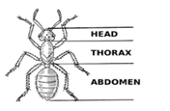  invertebrates, arachnids and insects, along with learning  how to classify plants.  We will also be looking at different habitats and studying ‘changing environments’ amongst the Earth. Children will learn about the positive and negative effects that humans can have on the environment and discuss the changes  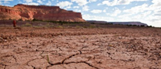  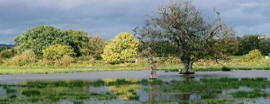    they might make to help in the future.
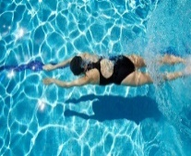  PE & Games:  This term’s PE is Team Building Invasion Games (Monday) and Swimming (Wednesday).  Please ensure that your child comes to school in their PE kit on Mondays. They will stay in their PE kit all day. If children wish to come to school with their swimwear under their uniforms on Wednesdays they may, but remember to pack your underwear in your swim bag for after the lesson! These decisions have been made in order to maximise the amount of time spent in the PE lesson. | Key Dates:  W/c Mon 3rd Nov - School Council Elections  Tues 4th Nov - Individual Photographs  Thurs 6th November - Parent Teacher Meet 3.30-6pm  Mon 10th Nov - Odd Socks Day  Tues 11th Nov – Parent Teacher Meet 3.30-6pm    Fri 28th Nov – Break the Rules Day  Fri 5th Dec – Carols @ Church  Fri 12th Dec – Travelling Christmas Theatre Visit  Thurs 18th Dec – Term Ends |  | Additional Learning:  Our D&T topic this half term is Cooking and Nutrition when we will be designing and baking a Christmas biscuit. In RE the children will be learning about why Jesus is inspirational to so many people. We will be completing a Glockenspiel unit of work in Music and creating Power Prints by experimenting with different drawing techniques in Art. Our French lessons will teach us how to say the months of the year, describe when it is our birthday and discuss the weather. In Computing we will look at the repetition of shapes and in PSHE Ed learn how to solve problems that we may encounter in life.
How you can help at home:
- Practise the Spellings that we have been focusing on in class including access to an online quiz that will be set and tested on Fridays.
- Mathletics tasks will continue to be set every Friday to be completed by the following Thursday.
- Log onto TTRockstars regularly to develop times table skills. A times table timed activity will take place every Friday. This is increasingly important for the Year 4 children who will complete the government set Timetables Check in June.
- Reading for 15-20 minutes four times during the week (Please ensure that an adult has signed your child’s reading record).
.

