
Information for Parents and Carers
Class 4: Autumn Term 2

  “Why has Brazil got one of the world’s fastest growing economies?”  Geography: Following on from our learning about the Amazon Rainforest, the children will explore the link between the Amazon and Brazil’s growing economy. They will learn about people who benefit from deforestation and those who campaign against it. We will use this work to inspire some persuasive writing. |  |  |  | English:  This half term, we’ll continue to read The Explorer as our class book as well as looking at The Origins of Species, Charles Darwin by Sabina Radeva linked to our science unit. The children will continue to work on reading and comprehension skills, alongside discrete spelling using ELS and grammar learning to support our written work.
Maths:    In Maths, we will continue with our work on fractions finding equivalents, comparing, ordering, adding and subtracting. Then we will revisit multiplication and division and master long multiplication and chunking, bus stop for division. Finally, we will finish the term by returning to fractions by multiplying and dividing them. Alongside our white rose maths curriculum the children will have access to weekly arithmetic assessment and practice and will develop core skills. |  | 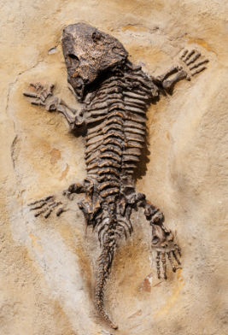  Science:  In science this term we will be focusing on ‘Evolution and Inheritance’ which will link closely with our English unit. The children will learn about ways that the Earth and living things have changed over time and how fossils can be used to find out about the past. They will explore how animals and plants are adapted to suit their environment and how this links to evolution. They will also learn about reproduction and offspring - recognising that offspring normally vary and are not identical to their parents.
PE & Games:  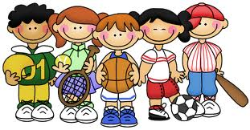  This half term’s PE will be on Netball & Basketball on Mondays and Tennis on Thursday. Please ensure that your child has both indoor and outdoor kit in school at all times, as plans can change if the weather is poor. Please provide outdoor trainers and bobbles to tie back long hair. Children should remove their earrings or bring plasters to cover them if they can’t be taken out. Smart watches are to be covered with a sweatband or taken off. |  |  | Cross Curricular Learning:  Our RE unit this half term is a trial of our new RE curriculum, commencing in 2026: How and why do Jewish communities celebrate festivals?  In French, the children will learn some vocabulary to talk about animals. Our PSHCE work this half-term will include anti-bullying week – odd socks day. Our Music unit will be based on ‘Make you feel my love’ by Adele whilst some children prepare for Young Voices with the choir. In Design & Technology, the children will be creating a stuffed animal in textiles.
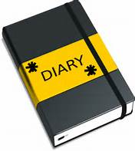  Class 4 - Dates for your diary:  - 10th Nov: Odd socks day  - 28th Nov: Break the Rules Day  - 5th Dec: Christmas at Church 9.30-10.30  - 12th Dec: Visiting Theatre Christmas Show  - Thursday 18th Dec: Final day of term |   How you can help at home  - Class 4 home-learning will be set on Fridays and should be submitted by the following Thursday.  - It will usually consist of a piece of Maths and English work to consolidate the learning in class: It will be set on Google Classroom. Please feel free to add your own comments to your child’s submitted work if you want to let me know how they got on, what they enjoyed and any issues that cropped up so that I can follow it up.  - There will also be a set of spelling words linked to ELS for the children to practise for a spelling test each Friday.  - For extra maths problem solving activities, there are great websites like www.nrich.maths.org and www.parallel.org.uk and the White Rose website has a ‘Problem of the Day’ www.whiterosemaths.com/resources/classroom-resources/problems/  - You may want to take a trip to Manchester Museum over the next few weeks to enrich their English and Science work.  - Finally, it cannot be underestimated how important it is for your child to READ AND BE READ TO regularly. Please encourage them to read and share books with you to build their confidence, fluency, and passion for reading!

