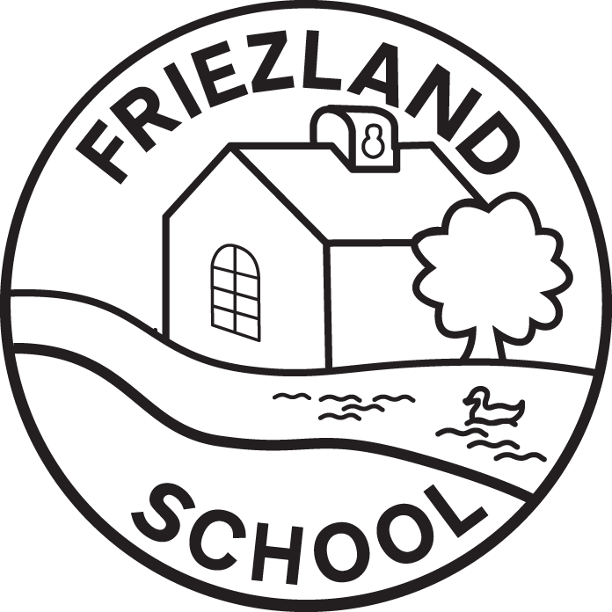

Curriculum Offer

Reviewed by | R Hammond
Date reviewed | September 2025
Date of next review | September 2026
Headteacher | R Hammond
Chair of Governors | J Goodwin

Curriculum Intent
“A Family Committed to Making a Difference”
Friezland Primary School is committed to improving outcomes for all pupils by delivering a curriculum which promotes a life-long love of learning; ensuring our curriculum is relevant, dynamic and enjoyable. We are passionate about developing skills for life which will develop well-rounded, resilient individuals who demonstrate mutual respect and tolerance and who have a positive impact on the wider community and wider world, to ensure successful citizens of the future.
We use the 2014 National Curriculum as a starting point for wide and varied learning experiences for our children. We enrich it with: an emphasis on outdoor learning; an understanding of the importance of British Values, and a sense of awe and wonder about the world in which we live.
We are committed to developing the whole child and expanding each pupil’s cultural capital. We have high expectations of all our children and ensure that, throughout their time at primary school, they will have the opportunity to be creative, physically active and academically challenged.
This policy should be read in conjunction with:
- Individual Subject Policies
- SEND Policy
- Equalities Policy
- Feedback and Marking Policy
The aims of our curriculum are to:
• promote high standards in reading, writing and maths;
• enable children to acquire knowledge and skills in science;
• enable children to be confident in the use of computing;
• promote social, spiritual, cultural and moral development;
• promote physical and mental development and an awareness of the importance of a healthy lifestyle;
• enable children to be aware of the importance of, and participate in, the arts and related cultural themes;
- expand pupil’s cultural capital;
• enable pupils to develop moral sensibility through carefully taught values and through school ethos;
• develop the personal and social skills of each child;
• provide equality of access and the opportunity for all pupils to make progress, and to
• prepare pupils for the opportunities, responsibilities and experience of adult life.

The curriculum is planned carefully to provide continuity and progression, as set out in each subject progression grid with key knowledge identified.
The Implementation of the Curriculum
Our curriculum is taught through a mixture of discrete subject lessons and cross-curricular lessons, using the humanities as the joining link, often starting with an enquiry question to engage learners and stimulate their natural curiosity. Our curriculum in Key Stage 1 and 2 is taught on a two-year cycle to cater for mixed-age group classes. Teachers ensure children are taught according to their ability rather than age, using a variety of teaching styles and personalised learning approaches. Planning uses the statutory guidance for the National Curriculum and the guidance for PSHE Education, RSE and RE.
To implement our curriculum, we have taken careful consideration of where and when subject topics/themes will be delivered. Statutory elements (such as teaching History pre-1066 in chronological order) have helped to shape the sequence of learning throughout each Key Stage.
Our curriculum is broad and balanced involving a wide range of experiences that develop all areas of skill, knowledge and understanding. Throughout a pupil’s time at Friezland, the following skills will be developed:
• Reading, writing, speaking, listening and numeracy
• Observation, recording and drawing
• Locating, retrieving, evaluating and using information from a range of sources
• Problem solving
• Practical application of skills
• The use of information and communication technology
- Learning another language (French)
• Planning and evaluating work to improve it
• Independent learning
• Creative and critical thinking
• Interpersonal skills
• Critical appreciation of the work of others and themselves
• Emotional literacy
• Aspirations for the future

Enrichment
In creating a broad and balanced curriculum, we feel it is essential for pupils to have a range of experiences during their time at Friezland School. These could include: visits in the local area (including walks); visits beyond the local area; visits to school by experts; outdoor and adventurous activities in KS1 and KS2; residential visits for Y6; financial/enterprise experiences; school plays and concerts for performance experience; opportunities to learn to play a musical instrument (brass, strings, percussion); involvement in charity events and opportunities for local community involvement.
The school offers a wide range of extra-curricular activities throughout the year, catering for all Key Stages. Some of the types of activities offered include a range of sports clubs and music tuition.
Inclusive Curriculum
We aim to provide access and opportunity for all pupils who attend the school, as stated in our SEND policy. Our school strives to meet individual needs, initially through High Quality Teaching. We comply with the requirements set out in the SEND Code of Practice in providing for children with special needs.
If a child is working beyond the expectations for his/her year group, he/she will be given appropriate challenge, including open-ended questions and tasks and opportunities to demonstrate mastery of the curriculum.
Early Years Foundation Stage (EYFS)
Our curriculum planning in EYFS is defined by the Eary Years Foundation Stage (EYFS) framework and focusses on developing children’s skills and experiences. Our school supports the principle that young children learn through play, and by engaging in well-planned activities. Teaching in the Reception class builds on any prior experiences of the children from their pre-school learning. Children’s interests are stimulated and their needs responded to through positive interactions and secure routines. Staff ensure a strong foundation in the prime areas of learning (Communication and Language, Physical Development, Personal, Social and Emotional Development) and specific areas (Literacy, Mathematics, Understanding the World, Expressive Arts and Design) are used to provide a broad and balanced curriculum and to practice development in prime areas, particularly language and vocabulary.
Assessment plays an important part in helping parents, carers and practitioners to recognise children’s progress, understand their needs, and to plan activities and support. Ongoing assessment is an integral part of the learning and development process. It involves staff knowing children’s levels of achievement and interests, and then shaping teaching and learning experiences for each child, reflecting that knowledge. In their interactions with children, staff respond to their own day-to-day observations about the children’s progress and draw on their knowledge of the child and their own expert professional judgement. Learning Journeys are compiled for each child on Tapestry, as a record of ‘WOW’ moments and progress, but this does not involve the collation of extensive evidence and paper trails. The Learning Journey is used alongside staff knowledge and professional judgements of a child, to inform discussions with parents, carers and other adults.

5Impact
Our broad and balanced curriculum helps to prepare our children for life beyond Friezland School. We aim for our pupils to become well-rounded citizens and to always consider the next steps of their journey.
We regularly assess our children’s learning in order to see any gaps in pupils’ understanding, as well as deepen learning for those who are exceeding age-related expectations.
Monitoring and Evaluation
Our curriculum offer is reviewed annually by teaching staff to allow us to adapt to our learners’ needs, address any barriers to learning and develop new lessons based on available resources or the most up to date research.
The Feedback and Marking Policy is monitored by senior leaders, Governors and subject leaders during monitoring and moderation activities.
Guidelines specific to the subjects of English and Maths can be found within the respective policies.
Data Protection Statement
The procedures and practice created by this policy have been reviewed in the light of our Data Protection Policy. All data will be handled in accordance with the school’s Data Protection Policy.
Data Audit for the Curriculum Offer Policy
What? | Probable Content | Why? | Who? | Where? | When?
Pupil feedback comments | Pupil name / class on exercise books  Written comments relating to progress / next steps | Monitor a child’s progress and identify next steps / adapt curriculum offer when required | All Staff  (as necessary) | Pupil exercise books / written activities | Pupils take exercise books home at the end of academic year.  Some books are held in school for monitoring purposes.
As such, our assessment is that this policy:
Has Few / No Data Compliance Requirements | Has A Moderate Level of Data Compliance Requirements | Has a High Level of Data Compliance Requirements
✓

