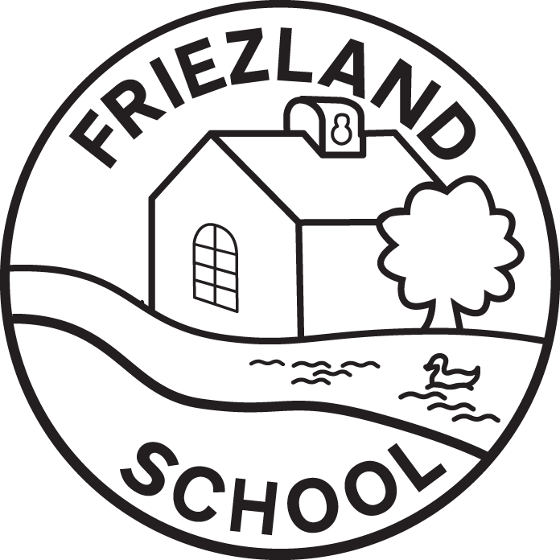

Remote Learning

Reviewed by | R Hammond
Date reviewed | April 2026
Date of next review | January 2029
Headteacher | R Hammond
Chair of Governors | J Goodwin

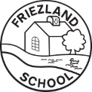

Remote Learning School Offer

‘A Family Committed to Making a Difference’: all stakeholders at Friezland are fully committed to improving teaching and learning in order to improve the outcomes for our pupils.

Friezland will use ‘Google Classroom’ for Year 1-6 and Tapestry for Reception as our learning platforms for any remote learning. Remote learning may occur: if a child is unable to attend school due to a medical reason but is well i.e. broken bone; for extreme weather school closures; for H&S school closures (i.e. no water / heat); industrial action (although this is not guaranteed).

All parents in Reception are issued with login details for Tapestry on joining the school and instructions on how to use the platform are shared as part of the welcome pack and welcome meeting. Pupils from Year 1 upwards are issued with log-in details for Google Classroom, as the platform is used for setting homework and sharing other class related documents. A series of ‘help’ sheets are provided to help families log on from home and pupils are taught how to use the platform in school as part of their Computing lessons.

To support effective Remote Learning, Friezland will:

- use a curriculum sequence that allows access to high-quality online and offline resources that is linked to the school’s curriculum expectations;
- plan a programme that is of equivalent length to the core teaching pupils would receive in school. For Primary School pupils the Government’s expectation for KS1 is three hours per school day, on average, with less for younger children. For KS2, the expectation is four hours per school day;
- give access to high quality remote education resources;
- select the online tools that will be consistently used across the school in order to allow interaction, assessment and feedback, and make sure staff are trained in their use;
- provide printed resources, such as textbooks, workbooks and learning packs, for pupils who do not have suitable online access and / or prefer to access learning in a concrete form;
- recognise that younger pupils and some pupils with SEND may not be able to access remote education without adult support or careful differentiation;
- set learning tasks so that pupils have meaningful and ambitious work each day in a number of different subjects (typically a Maths, English and at least one other subject set daily), ensuring a focus on wellbeing and PSHE activities is at the foundation;
- teach a planned and well-sequenced curriculum so that knowledge and skills are built incrementally, with a good level of clarity about what is intended to be taught and practised in each subject;
- provide frequent, clear explanations of new content, delivered by a teacher in the school or through high quality curriculum resources;
- develop ways of lesson delivery in order to maximise pupil engagement and enthusiasm including: live lessons or pre-recorded input;
- gauge how well pupils are progressing through the curriculum, using questions and other suitable tasks;
- support regular communications between the pupil and their teacher (GC feedback / email / phone call / video call where applicable);
- provide regular pupil learning feedback through staff (Teacher / TA) comments, submitted through Google Classroom/Tapestry. In the vast majority of cases, pupils will receive feedback during the same school day. Depending on when afternoon activities are submitted, they may receive feedback the following school day. Some activities will receive specific feedback, others will receive generic feedback and some will be recorded as ‘seen and submitted’, by a member of staff.
- enable teachers to adjust the pace or difficulty of what is being taught in response to questions or assessments, including, where necessary, revising material or simplifying explanations to ensure pupils’ understanding;
- avoid an over-reliance on long-term projects or internet research activities;
- avoid activities which place significant demands on parents’ help or support, acknowledging that a school closure will bring additional challenges and pressures to home life and
- incorporate wellbeing check-ins with any pupil who isn’t engaging with learning or indicates they are having particular difficulties.

Friezland will consider these expectations in relation to the pupils’ age, stage of development and/or special educational needs.

