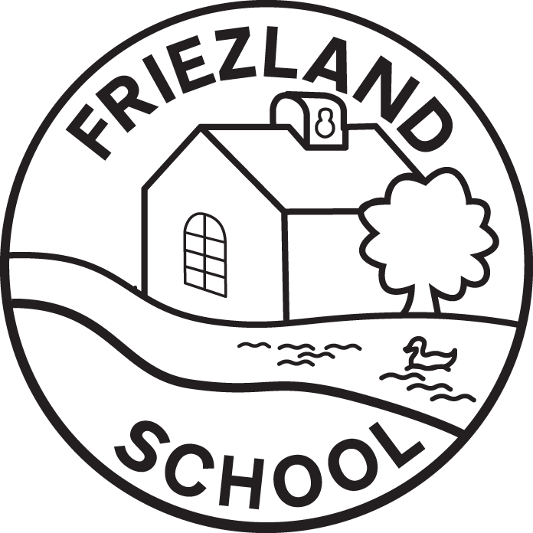

Use of AI in School Policy
Written / Reviewed by | Rebecca Hammond
Date written / reviewed | April 2026
Date of next review | April 2027
Headteacher | R Hammond
Chair of Governors | J Goodwin
Data Protection & Digital Champion Governor | S Chapman



Use of Artificial Intelligence in School

This policy sets out Friezland Primary School’s approach to the safe, ethical and proportionate use of Artificial Intelligence (AI). It reflects Department for Education (DfE) guidance and aligns with the Ofsted Education Inspection Framework, including the November 2025 inspection toolkit, with a strong emphasis on safeguarding, curriculum integrity, professional judgement and leadership oversight.

Where AI is used at Friezland Primary School, it supports curiosity, creativity and exploration, but never replaces relationships, human interaction or high-quality teaching. All use of AI must reflect our commitment to dignity, wisdom, community and responsibility.

The purpose of this policy is to ensure that any use of AI:
- Supports high-quality teaching and learning
- Upholds safeguarding as a priority
- Reflects the school’s ethos and moral responsibility
- Maintains educational integrity and fairness
- Is subject to professional judgement and leadership oversight

This policy applies to all pupils, staff (including supply staff), governors, volunteers and contractors. It should be read alongside the Safeguarding and Child Protection Policy, E-Safety Policy, Data Protection (GDPR) Policy, Acceptable Use Policy, Behaviour Policy and Staff Code of Conduct.

Staff should refer to Appendix A: Staff FAQ on Using Microsoft Copilot Safely, as part of induction and ongoing training to support the safe use of AI and compliance with this policy.

Definition of Artificial Intelligence:
Artificial Intelligence refers to digital tools or systems that generate content, analyse information or support decision-making through automated processes. In education, this may include text generators, chatbots, image generators, analytics tools or adaptive learning software.

Our Core Principles:
- Safeguarding first: pupils’ safety and wellbeing are paramount.
- Human oversight: AI supports but never replaces professional judgement.
- Educational integrity: pupils’ work must reflect their own learning.
- Transparency: pupils understand when AI is being used and why.
- Inclusion and fairness: AI must not disadvantage any pupil.
- Data protection: personal data must never be entered into AI systems.

Use of AI with Pupils:
AI may be used with pupils only where it is age-appropriate, purposeful and supervised. Examples include teacher-led modelling, generating examples for critique, or supporting accessibility.
AI must not be used to complete work presented as pupils’ own learning, replace the teaching of core skills, or allow pupils to input personal data. This reflects Ofsted’s expectation that learning outcomes demonstrate secure understanding rather than artificial performance.

Use of AI by staff:
Staff may use AI to support planning, administration and professional reflection. All outputs must be critically evaluated, adapted to the school context and checked for accuracy and bias. Responsibility for curriculum quality, intent, implementation and impact remains with staff and leaders.
Staff may use Microsoft Copilot with their school login for tasks involving personal data. All other types of AI and related tools should not be used, including Copilot from a personal account.
AI must not be used to generate assessed work presented as independent pupil learning. Where concerns arise, these will be addressed through professional discussion and existing assessment and behaviour procedures, with a focus on education rather than punishment.

Safeguarding and Online Safety:
AI use forms part of the school’s safeguarding and online safety framework. Any concerns relating to misuse, exposure to inappropriate content or potential harm will be managed in line with safeguarding procedures.

Data Protection and GDPR:
Staff must not upload personal, confidential or safeguarding-related information into AI tools, other than MS Copilot used in conjunction with a school login. Microsoft Copilot is safe for personal or sensitive information because: it stays fully inside the school’s secure Microsoft 365 environment; it follows all existing permissions and safeguarding controls; it does not train on your data and it is fully GDPR‑compliant.

Leadership, Governance and Monitoring:
Senior leaders and governors monitor the use of AI as part of safeguarding and curriculum oversight. The focus is on evaluating impact, managing risk and ensuring practice reflects the school’s values and statutory responsibilities.

Training and Awareness:
The school will ensure staff receive guidance on appropriate AI use, pupils develop understanding of AI through digital literacy and online safety, and governors remain informed of developments and risks.

Review:
This policy will be reviewed every two years, or sooner in response to changes in DfE guidance, Ofsted expectations or emerging risks.

Appendix 1:

Friezland Primary School

Staff FAQ on Using Microsoft Copilot Safely

1. What is Microsoft Copilot?
Microsoft Copilot is an AI assistant built inside our school’s Microsoft 365 system. It works within Word, Outlook, Teams and other apps to help with drafting, summarising, creating resources and reducing workload.

2. Why can we use Copilot with personal or sensitive information?
Because Copilot runs entirely inside our school’s secure Microsoft 365 environment, not on the public internet.
This means:
- It uses your existing Friezland staff login (Microsoft Entra ID).
- It only accesses files and data you already have permission to see.
- It does not store or reuse information outside our organisation.
- It follows all the same GDPR, security, and safeguarding protections already built into Microsoft 365.
Public AI tools do not offer these protections.

3. What makes Copilot different from public AI tools like ChatGPT or Gemini?
Microsoft Copilot (School Account) | Public AI Tools (e.g., ChatGPT, Gemini)
Runs inside Microsoft 365 | Runs on the open internet
Follows school permissions & GDPR | No link to school systems or controls
Does NOT train on your data | May store or train on your inputs
Safe for pupil & staff personal info | Not safe for any personal data
Fully monitored & auditable | No safeguarding oversight
Bottom line: Copilot is approved for sensitive data; public AI tools are not.

4. What kind of tasks can I safely use Copilot for?
You can use Copilot to help with:
- Writing letters, reports, emails
- Summarising meeting notes or long documents
- Drafting policies or curriculum materials
- Creating lesson plans or ideas
- Analysing data (e.g., attendance patterns)
- Preparing newsletters or website text
- Simplifying or adapting language for families
These tasks are safe even if personal information is involved, provided you are using Copilot via your school Microsoft account.

5. What should I not use Copilot for?
- Generating work pupils submit as their own
- Asking it to make decisions for you (especially safeguarding decisions)
- Entering personal information when using any AI tool outside Microsoft 365
- Uploading images or documentation containing personal data into public AI platforms
- Creating fictional pupil records or guessing information
Copilot is a helper — not a decision-maker.

6. Can Copilot see everything in the school system?
No. Copilot is restricted by the same file permissions you already have.
If you cannot access a document, neither can Copilot.

7. Does Copilot learn from what I type into it?
No. Prompts, files, and responses are not used to train Microsoft’s foundation models.
Copilot only uses your input temporarily to create your output.

8. Is pupil data safe when using Copilot?
Yes — as long as you use Copilot via your school Microsoft 365 login.
It is covered under:
- Microsoft’s enterprise GDPR commitments
- Microsoft 365’s encryption and data protections
- School and LA data-processing agreements
However, you must still apply professional judgement when working with sensitive issues.

9. Can pupils use Copilot?
Not automatically.
Pupil use must be:
- Age appropriate
- Supervised
- For learning, not replacement of learning
- Without entering personal data
Any pupil access should be pre-agreed with SLT.

10. Should Copilot be used for safeguarding decisions?
No.
You may use it to help:
- Draft reports
- Summarise long documents
- Organise information
But safeguarding judgement must ALWAYS be made by staff, not AI.

11. Can I use ChatGPT, Gemini, or other tools for planning?
Yes — but NOT with personal, sensitive or school-specific information.
Safe example:
✔ “Write a Year 5 lesson starter about fractions.”
Unsafe example:
✘ “Write a behaviour plan for a child called ____.”
When in doubt, use Copilot instead.

12. What do I do if I think I entered something into the wrong tool?
Tell SLT or the DSL immediately.
Mistakes happen — reporting quickly helps us keep everyone safe and compliant.

13. Where can I get support or training?
Ask SLT, the Digital Lead, or the Business Manager.
We can also provide short walkthroughs or examples at staff meetings.

